Name: Shanne Edralyn N. Erandio Date: 11/27/2025
Course, Year and Section: BSIT 2A

Assembly Programming
Case Study 5: Largest of Three Numbers

Write an Assembly program that:
- Takes three single-digit inputs
- Compares them
- Displays the largest number
- Use conditional jumps (JG, JL, JE) or CMP instructions.
Code and Output
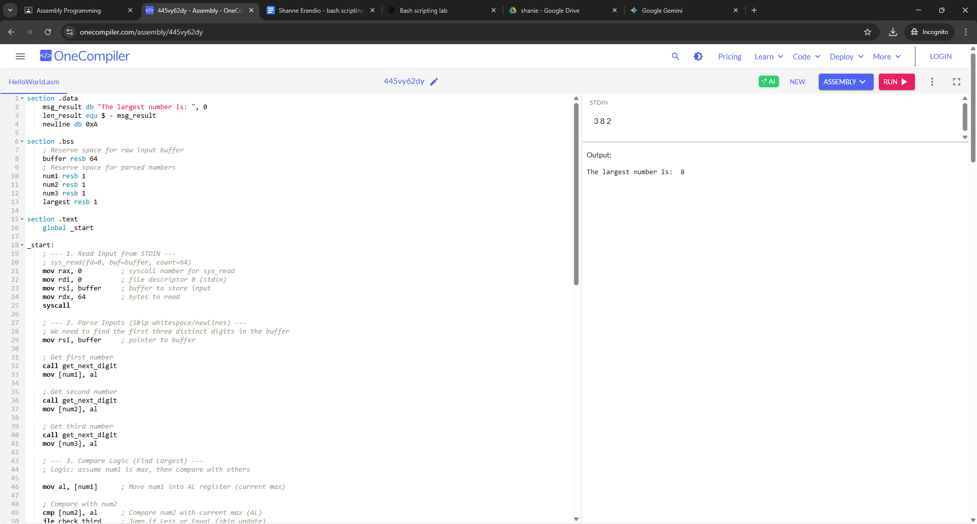

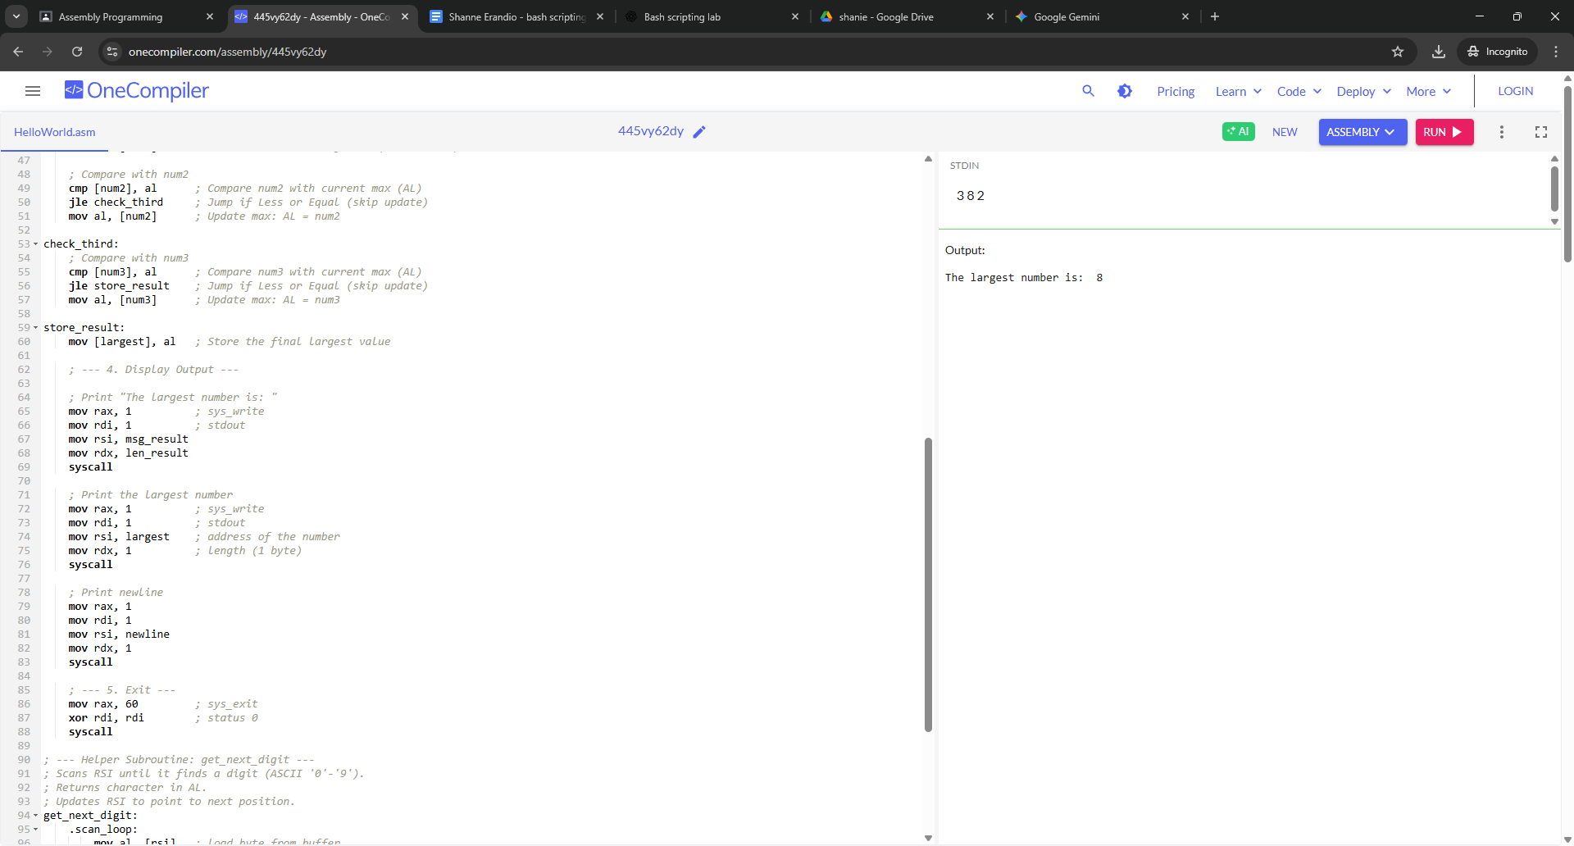

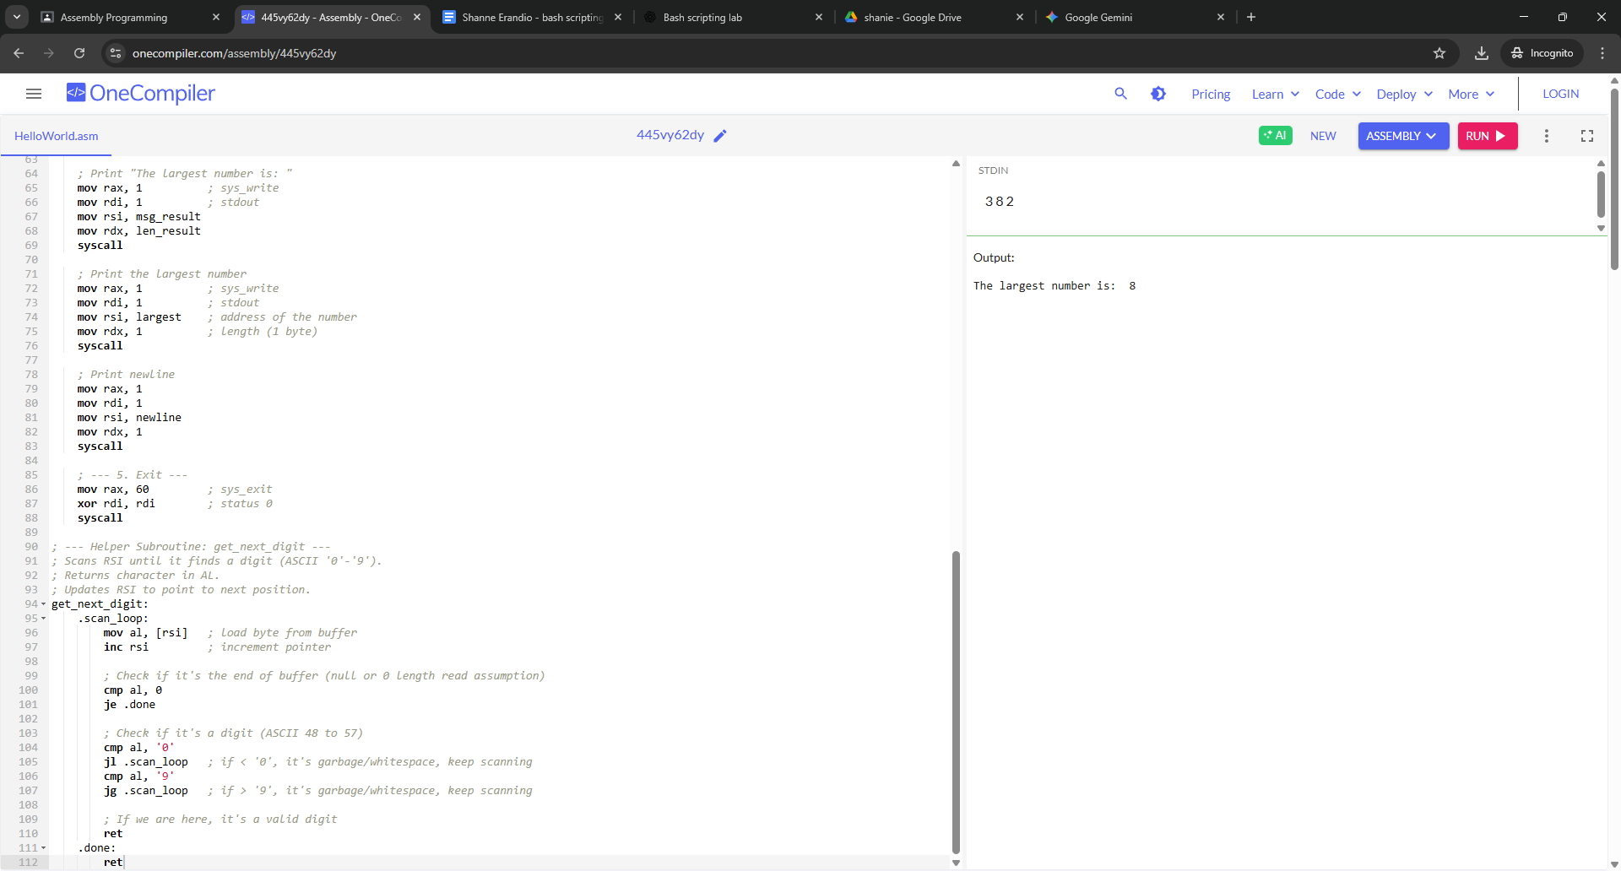

In this activity, I learned how Assembly handles input, comparisons, and output at a very low level using system interrupts. Writing a program to determine the largest number helped me understand the use of CMP and conditional jump instructions like JG and JL. I also learned how ASCII values must be converted before comparing numbers. Overall, this exercise improved my understanding of how high-level logic is translated into step-by-step CPU operations.

The primary goal of this case study was to implement conditional logic in a low-level language. Unlike high-level languages where if/else structures are built-in, Assembly requires the programmer to manually manage control flow using the processor's status flags and jump instructions. The specific task was to determine the largest of three single-digit integers provided via standard input.
This exercise highlighted the trade-offs of Assembly language. While it offers precise control over registers and execution flow, it demands explicit management of trivial tasks like parsing ASCII characters and skipping whitespace. Mastering CMP and conditional jumps (JG, JL, JE) provides a fundamental understanding of how computer processors actually make decisions at the hardware level.

